## Curtin University – Department of Computing

## **Assignment Cover Sheet / Declaration of Originality**

## Complete this form if/as directed by your unit coordinator, lecturer or the assignment specification.

| Last name: | Bevacqua | Student ID: | 20162896 | |
| --- | --- | --- | --- | --- |
| Other name(s): | Austin | | | |
| Unit name: | Capstone Computing Project 1 | Unit ID: | ISAD3000 | |
| Lecturer / unit coordinator: | Senjian An | Tutor: |  | |
| Date of submission: | 05/04/2022 | Which assignment? | Milestone 4 | (Leave blank if the unit has only one assignment.) |

## I declare that:

## · The above information is complete and accurate.

## · The work I am submitting is *entirely my own*, except where clearly indicated otherwise and correctly referenced.

## · I have taken (and will continue to take) all reasonable steps to ensure my work is *not accessible* to any other students who may gain unfair advantage from it.

## · I have *not previously submitted* this work for any other unit, whether at Curtin University or elsewhere, or for prior attempts at this unit, except where clearly indicated otherwise.

## I understand that:

## · Plagiarism and collusion are dishonest, and unfair to all other students.

## · Detection of plagiarism and collusion may be done manually or by using tools (such as Turnitin).

## · If I plagiarise or collude, I risk failing the unit with a grade of ANN (“Result Annulled due to Academic Misconduct”), which will remain permanently on my academic record. I also risk termination from my course and other penalties.

## · Even with correct referencing, my submission will only be marked according to what I have done myself, specifically for this assessment. I cannot re-use the work of others, or my own previously submitted work, in order to fulfil the assessment requirements.

## · It is my responsibility to ensure that my submission is complete, correct and not corrupted.

| Signature: | AUSTIN BEVACQUA | Date ofsignature: | 06/05/2022 |
| --- | --- | --- | --- |

## 

*ISAD3000 Capstone Computing Project Milestone 4 Individual Report*

***Austin Bevacqua***

***Group E8: Amristar Industry Project [Virtual Jukebox]***

Group Members:

Austin Bevacqua, Bradley van der Zwan, Dillon Vincent,   
Ryan Webster, Tanaka Chitete

## 

## 

## 

## 

## Progress Tracking

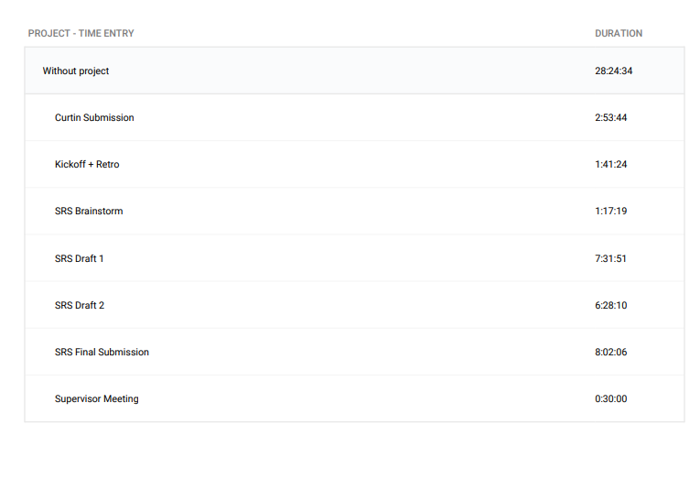

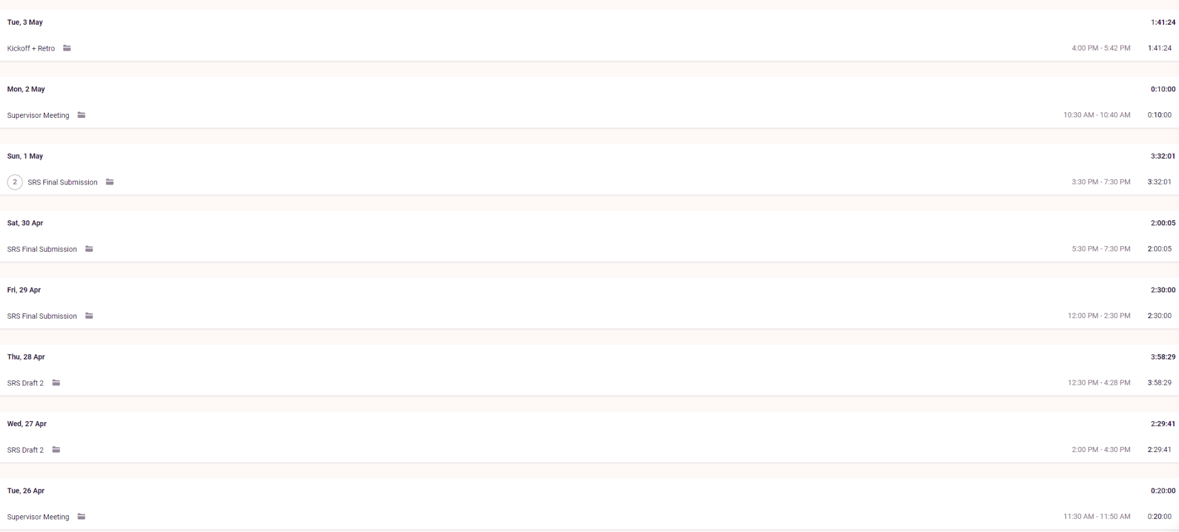

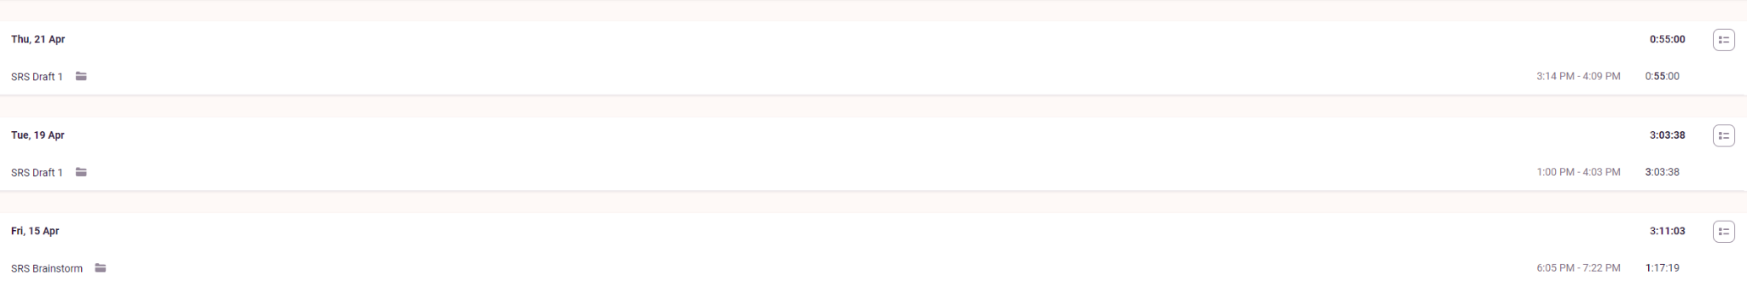

**Supervisor Meetings (26th April, 2nd May)**

Took part in supervisor meetings with Amristar. Discussed was the ongoing progress of the SRS, and the upcoming submission of the SAS

Minutes taken by Bradley

<https://drive.google.com/drive/folders/1rKsgHWpck5Wpd935lpXTCyADSaPFoQgS?usp=sharing>

**Sprint Kickoff (3rd May)**

Sprint kickoffs were run and organised by myself. As our sprints are two weeks long, we discussed what we would be doing the next two weeks, and put these goals into tickets. We then did story point allocation, and assigned these tickets to a person.

Minutes for these meetings were written down by Bradley, who has included these documents in the group report.

<https://drive.google.com/drive/folders/1OImhOwUw_PIgKJ7r6JA-oma24w2zfaJa?usp=sharing>

**Sprint Retrospective (3rd May)**

Sprint retrospectives were run and organised by myself. As our sprint was three weeks long, we reflected on how the last 3 weeks had gone, and came up with action items to improve on the next sprint. Retrospective meetings were run by having group members write down what they thought went well, and what could be improved on for the sprint. Every group member was then given 3 votes, and we discussed the highest voted cards.

Minutes for these meetings were written down by Bradley, who has included these documents in the group report.

<https://drive.google.com/drive/folders/1OImhOwUw_PIgKJ7r6JA-oma24w2zfaJa?usp=sharing>

**Scrum Meetings (15th, 18th, 28th, 30th April)**

Although no official Scrum meetings were held, the group met regularly to discuss the progress made on the SRS, and what still needed to be done. As these meetings were not traditional standup meetings, they are included in “SRS Draft x” and “SRS Final Submission” on Toggl.

<https://drive.google.com/drive/folders/1OImhOwUw_PIgKJ7r6JA-oma24w2zfaJa?usp=sharing>

**SRS Drafts 1 + 2 (19th - 28th April)**

Progress made on the SRS deliverable. This includes formatting, functional requirements, nonfunctional requirements, defining actors, ect…

I wrote the functional requirements, and formatted the functional and nonfunctional requirements based on the Amristar feedback.

Edit history for the document, including both drafts, can be seen here.

<https://docs.google.com/document/d/1CQ3ZUu5cgSV7MMw2JtgrXopPUMZS4N3i/edit>

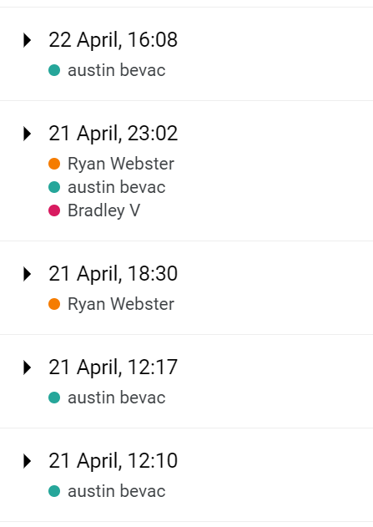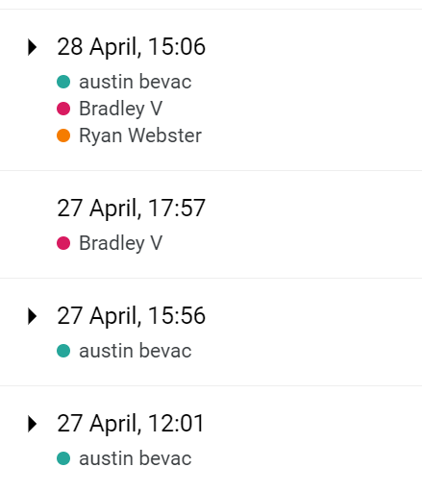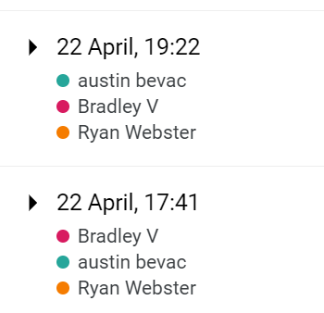

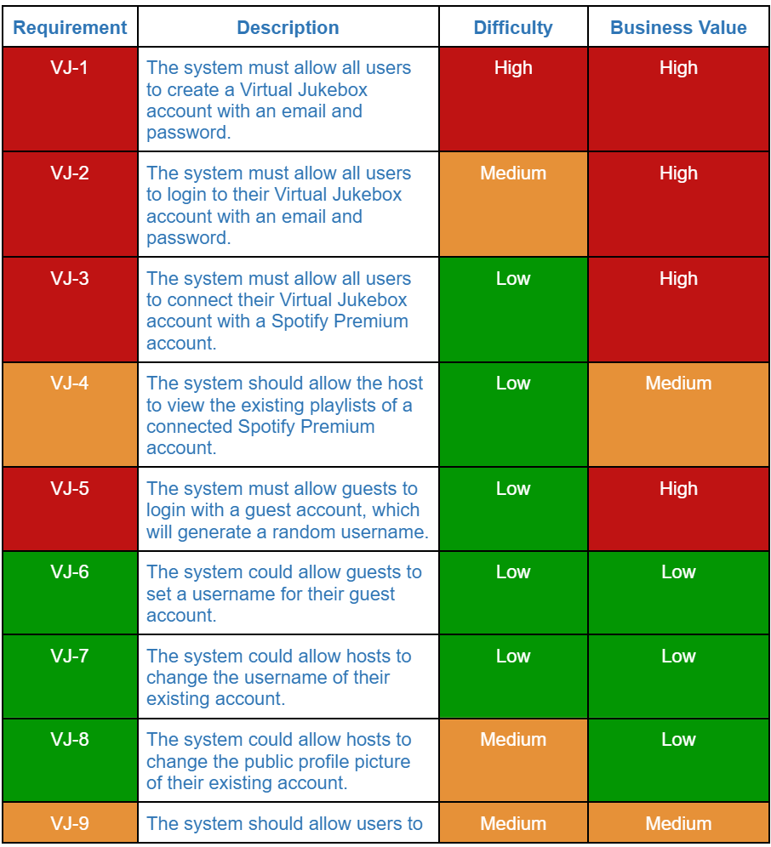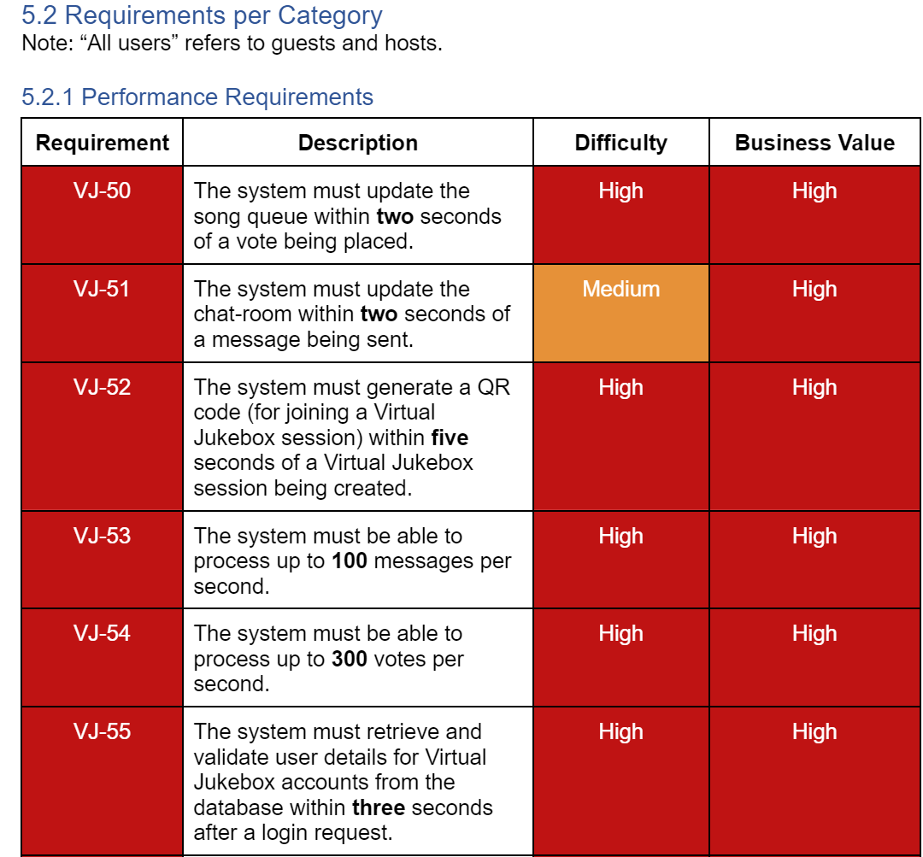

**Final SRS Submission + Project Plan (29th April - 1st May)**

Final iteration of the SRS, where the feedback from draft 2 was implemented.

The final submission also included work on the project plan, where I estimated story points for all ~200 tasks, and allocated people towards the tasks.

Included in “SRS Final Submission” on Toggl.

Submissions for the SRS Drafts can be seen at this link. Note edit history is not available as these are copies of the original document. To view edit history, view the document link above.

<https://drive.google.com/drive/folders/18p0U6w9yyfh61fs7rk_411_MaoRMnZaE>

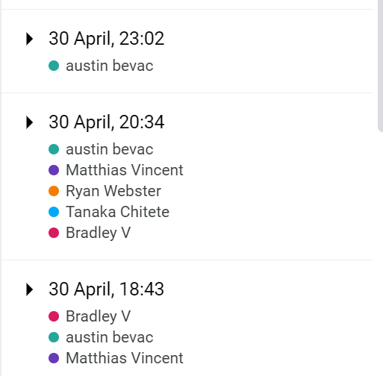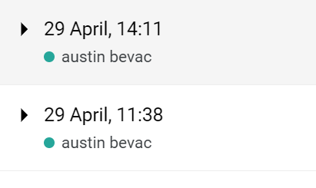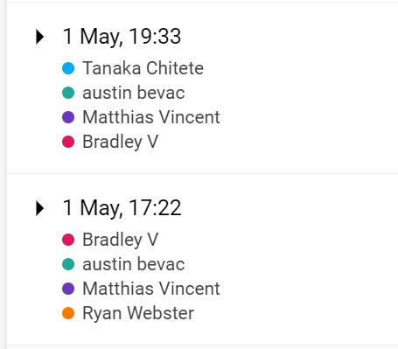

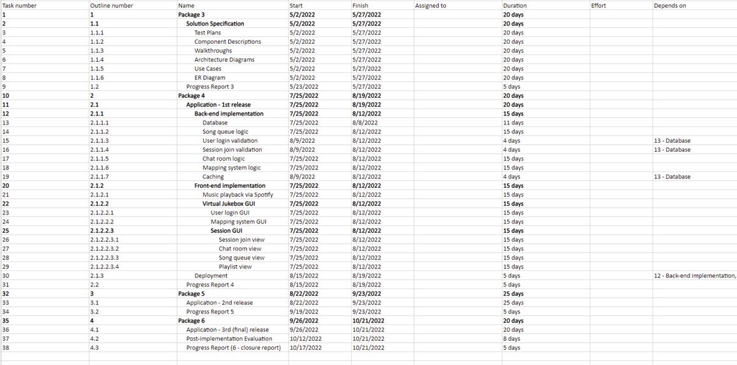

**Progress Report (1st May)**

In addition to the TIS, our group also had to submit a progress report detailing all of our group and individual work over the milestone period. I added my individual work to this document, which can be seen in the edit history.

Included in “SRS Final Submission” on Toggl.

**Curtin Milestone Submission (6th May)**

This document + group report, where I added my work over the previous period.

## Summary

Overall, this was an extremely busy period for our group and all members could not put as many hours in as we would have liked. Due to other units, covid isolation periods and having this deliverable be a 3 week period rather than 4 weeks, the group did amazingly well to submit a comprehensive SRS, project plan and progress report on time. It was difficult to keep track of individual progress, due to the collaborative nature of the SRS, but next deliverable with the SAS, it will be easier to assign tasks and track individual progress.